
ABSTRACT

The Smart Stick is a revolutionary IoT-based assistive device meticulously crafted to enhance the safety and autonomy of visually impaired individuals. It integrates cutting-edge object detection technologies, intuitive feedback systems, and seamless connectivity to provide real-time assistance and navigation support.This project introduces the development of a Smart Stick, a transformative assistive device designed to elevate the safety and independence of visually impaired individuals. With a primary focus on real-time feedback mechanisms, the Smart Stick integrates state- of-the-art object detection technologies alongside an intuitive buzzer system, providing users with immediate awareness of obstacles in their path.
Through the integration of ultrasonic sensors, the Smart Stick swiftly identifies objects within the user's surroundings, activating a buzzer that emits auditory cues proportional to the proximity and direction of the obstacle. Leveraging advanced algorithms, this device ensures precise feedback, empowering users to navigate complex environments with confidence.In addition to object detection, the Smart Stick incorporates a robust fire detection mechanism, swiftly sensing heat signatures and smoke particles.
Equipped with a GPS module for accurate location tracking, the Smart Stick offers users the ability to monitor its real-time location through a dedicated mobile application. This functionality not only facilitates swift retrieval in emergencies but also provides peace of mind to users and their caregivers.
Moreover , the Smart Stick includes an integrated emergency button, allowing users to manually trigger distress signals. In emergency situations, the system automatically activates the alert notification feature, promptly notifying designated family members for immediate assistance.To address potential hazards such as uncovered holes or gaps in the user's path, the Smart Stick utilizes depth sensing technology, complemented by the buzzer feedback, ensuring comprehensive awareness of the surroundings.To further enhance user safety, the Smart Stick incorporates a vibration motor, providing tactile feedback to alert users of potential hazards, particularly beneficial for those with impaired hearing.

In conclusion, the Smart Stick represents a multifaceted solution poised to enhance the safety and independence of visually impaired individuals. By seamlessly integrating object detection, GPS tracking, and alert notification functionalities, this innovation empowers users to navigate their surroundings confidently while ensuring timely assistance in emergency situations, fostering inclusivity and support for all.

CHAPTER -01 INTRODUCTION

INTRODUCTION

A New Way to See the World:

Imagine a brightly illuminated Earth, a symphony of colors and shapes. Now, close your eyes. The vibrant world transforms into a landscape of textures and sounds—a place where moving around can feel uncertain and sometimes even unsafe. For many years, the white cane has been a trusted companion, helping people who are visually impaired to detect obstacles and navigate their surroundings. But even with all its reliability, the white cane has its limits. It can only tell you so much.
This project is about creating a special kind of cane—a Smart Stick—designed to help individuals who are visually impaired move with greater confidence, safety, and independence. By combining modern technology with thoughtful design, the Smart Stick aims to offer a better way to interact with the world.

The Challenges We Face:

Daily routines that many take for granted—like visiting a new shop, crossing a street, or simply enjoying a walk in the park—can be challenging for those who rely on touch and sound to navigate. The traditional white cane can identify immediate obstacles, but it cannot provide details like the type or distance of those obstacles. This lack of information can lead to hesitation, frustration, and a feeling of limitation.

A Brighter Idea: Introducing the Smart Stick

Technology is constantly evolving, and with it comes the opportunity to create innovative tools that can make a real difference. The Smart Stick is not just a cane—it's a step forward. It's packed with useful features designed to enhance mobility and safety for the visually impaired.

More Than Just Bumping: Enhanced Object Detection

Imagine walking down the street and having your cane tell you not only that there's an obstacle ahead, but also how far away it is. The Smart Stick uses advanced sensors to detect nearby objects and their distance. With this kind of detail, users can move more freely and with greater confidence.

Safety First: Improved Fire Detection

Fire safety is a serious concern, especially for those who may not see or hear traditional alarms. The Smart Stick includes a built-in fire sensor that detects smoke or heat and alerts the user through vibrations. There's also a help button that, when pressed, sends a message with your exact location to a chosen contact, ensuring that help can arrive quickly if needed.

Never Lost Again: Real-Time Location Tracking

The Smart Stick also features a real-time GPS tracker. Similar to the tracking feature in smartphones, this allows a user’s location to be seen through a connected mobile app. Family members or caregivers can check in to make sure their loved one is safe, especially when they’re in unfamiliar places.

Designed for You: Simple and Easy to Use

Above all, the Smart Stick is made to be user-friendly. With just a few easy-to-understand buttons and a gentle buzzer, it avoids complexity while delivering powerful functionality. The goal is to let users focus on the world around them, not on how to operate their device.

A Brighter Future

The Smart Stick represents more than just new technology—it’s about freedom, independence, and confidence. It’s about making the world more accessible and less intimidating for people who are visually impaired. With the Smart Stick, users gain not just a new tool, but a trusted companion on their journey toward a more connected and empowered life.

CHAPTER-02 LITERATURE SERVEY

LITERATURE SERVEY
Introduction

The literature related to assistive technologies for people with visual impairments showcases a vast and varied field of research, innovation, and practical use. Over the years, researchers have explored a range of technological solutions to address the specific challenges faced by individuals with visual impairments, particularly in areas of independent mobility, environmental awareness, and real-time feedback. This literature review presents a comprehensive overview of significant findings, trends, and technological advancements in assistive technology, with a primary focus on object detection systems and mobility aids, including emerging smart technologies like the Smart Stick.

Object Detection Systems

Object detection systems are designed to alert users to obstacles in their environment, reducing the risk of accidents and promoting safer navigation. In earlier stages of development, these systems relied heavily on basic sensors, such as ultrasonic and infrared technologies. Studies by Sonka et al. (1993) and Capson et al. (1996) demonstrated the potential of using ultrasonic sensors for detecting objects in the path of a user, laying the foundation for later improvements.

With the rise of artificial intelligence, particularly computer vision and deep learning, more advanced systems have emerged. Techniques such as YOLO (You Only Look Once) by Redmon et al. (2016) and Faster R-CNN by Ren et al. (2015) have enabled real-time object recognition with high accuracy, which is critical for quick and reliable feedback to visually impaired users.

Recent studies have explored integrating object detection with augmented reality (AR) and wearable technologies. Research by Kim et al. (2019) and Zhang et al. (2020) investigated smart glasses that use real-time image processing to identify objects and provide spoken or vibrational cues. These systems greatly enhance the user's spatial understanding and environmental awareness.
In addition to wearable formats, mobile-based object detection has gained traction. Apps using smartphone cameras and AI models are becoming more accessible, offering cost-effective alternatives to dedicated devices.

Mobility Aids

Traditional mobility aids, such as white canes and guide dogs, remain essential tools for navigation, offering simplicity, portability, and reliability. However, these aids offer limited situational awareness, especially in dynamic or unfamiliar environments.

To address these limitations, researchers have developed Electronic Travel Aids (ETAs) and smart canes that integrate sensors, microcontrollers, and user feedback mechanisms. Devices like the Sonic Pathfinder and Laser Cane (Kaufman et al., 1996; Ruff et al., 2010) utilize sonar or laser to detect obstacles, with results communicated via vibrations or audio tones.

Modern smart canes—like those discussed by Islam et al. (2018) and Aziz et al. (2021)—feature advanced components such as gyroscopes, accelerometers, and Bluetooth modules. These devices not only detect obstacles but also connect to smartphones, enabling location sharing, emergency alerts, and guided navigation.

A significant leap in mobility aid development has come from the incorporation of GPS navigation. Research by Chen et al. (2016) and Lee et al. (2018) investigated the use of GPS-enabled smart canes and voice-based navigation apps to provide real-time route guidance. Such tools assist users in unfamiliar environments and are especially helpful in urban areas with complex infrastructure.

User Experience and Design Considerations

Recent literature also emphasizes the importance of user-centered design. Many assistive devices fail to gain widespread adoption not due to technical flaws, but because of complexity, lack of comfort, or poor integration into users’ daily lives. Studies by Wang et al. (2017) and Singh et al. (2020) highlight that devices need to be intuitive, lightweight, and non-intrusive to be effective and accepted.

Moreover, usability studies have revealed that excessive audio feedback can overwhelm users, especially in noisy environments. Hence, combining multimodal feedback—such as gentle vibrations, customizable sounds, and tactile buttons—is now a best practice in device design.

Current Gaps and Future Directions

Despite significant progress, challenges remain. Many systems lack contextual awareness, meaning they may detect an obstacle but not provide details about what it is or how to navigate around it. In addition, integration of machine learning models on low-power embedded systems remains a technical hurdle, especially for portable devices like smart canes.

There is also a growing interest in combining assistive technologies with Internet of Things (IoT) capabilities. This can open the door to smart city integration, where traffic signals, bus stops, and public spaces are designed to communicate with mobility aids for a seamless experience.

Future research may also delve deeper into crowdsourced navigation data, where real-time inputs from users can help others avoid hazards or discover safer routes, further promoting community-based support.

The literature on assistive technologies for individuals with visual impairments reflects a dynamic and rapidly evolving field. From basic obstacle detection tools to intelligent, connected mobility aids, research continues to push the boundaries of what is possible. Object detection systems and mobility aids—especially innovations like the Smart Stick—represent a promising future for improving the independence, mobility, and confidence of people with visual impairments. As technological capabilities grow, the focus must remain on creating devices that are not only smart but also affordable, accessible, and user-friendly, paving the way toward a more inclusive world.

CHAPTER -03 STRUCTURE OF THE PROJECT

PROBLEM DEFINITION

The issue tackled by the Smart Stick project centers on the restricted mobility and autonomy faced by individuals with visual impairments while moving through their surroundings. Conventional tools, like white canes, offer some help but often fall short in providing real-time updates and complete support in ever-changing environments. Consequently, individuals with visual impairments encounter difficulties in identifying obstacles, avoiding hazards, and safely navigating unfamiliar areas.

Moreover, existing assistive technologies may be prohibitively expensive, inaccessible, or cumbersome to use, further exacerbating the mobility limitations experienced by individuals with visual impairments. Additionally, the lack of connectivity and integration with other devices and systems may hinder users' ability to access essential services, such as emergency assistance or real-time navigation guidance.

Thus, the problem addressed by the Smart Stick project can be summarized as follows:

  - Limitation of Mobility and Independence: Individuals with visual impairments face challenges in navigating their environments safely and independently due to the limitations of traditional aids and assistive technologies.

  - Limited Real-Time Feedback: Existing assistive technologies may not provide users with real-time feedback about their surroundings, making it difficult to detect obstacles and hazards in dynamic environments.

  - Accessibility and Affordability: Many assistive technologies for individuals with visual impairments may be inaccessible or prohibitively expensive, limiting their adoption and usability among the target population.

  - Connectivity and Integration: The lack of connectivity and integration with other devices and systems may hinder users' ability to access essential services, such as emergency assistance or real-time navigation guidance, further limiting their mobility and independence. Problem Definition (continued):

  - Safety Concerns: The inability to detect obstacles and hazards in real-time poses significant safety concerns for individuals with visual impairments, increasing the risk of accidents, injuries, and falls during navigation.

  - Limited Customization: Existing assistive technologies may not offer sufficient customization options to meet the diverse needs and preferences of individuals with visual impairments, limiting their effectiveness and usability in different environments and situations..

  - Psychological Impact: The challenges associated with limited mobility, independence, and access to information may have a profound psychological impact on individuals with visual impairments, leading to feelings of frustration, anxiety, and depression, further diminishing their quality of life and well-being.

Addressing these multifaceted challenges requires a holistic approach that combines technological innovation, user-centered design, accessibility, and collaboration with stakeholders, including individuals with visual impairments, caregivers, healthcare professionals, and policymakers. By developing a comprehensive and inclusive assistive device like the Smart Stick, we can empower individuals with visual impairments to navigate their environments safely, independently, and with dignity, ultimately enhancing their quality of life and promoting social inclusion and equality.

PROPOSED SYSTEM

The proposed system, known as the Smart Stick, serves as an advanced and inclusive assistive tool developed to overcome the mobility and independence issues encountered by individuals with visual impairments. By utilizing state-of-the-art technologies and user-focused design strategies, the Smart Stick strives to deliver real-time guidance, improve safety, and support self-reliance for users as they move through their surroundings.

- Obstacle Detection Mechanism: At the heart of the Smart Stick is an advanced object detection system comprising sensors, such as ultrasonic or infrared sensors, strategically positioned along the length of the stick. These sensors continuously scan the surrounding environment, detecting obstacles, hazards, and other objects in the user's path.

- Real-time Response System: Upon detecting obstacles or hazards, the Smart Stick's feedback system provides users with real-time auditory, tactile, or visual cues to alert them to potential dangers. For example, the system may emit audible beeps or vibrations that increase in frequency or intensity as the user approaches closer to an obstacle.

- GPS Tracking System: Equipped with a GPS module, the Smart Stick provides users with real-time location tracking capabilities, allowing them to navigate unfamiliar environments with confidence. Caretakers can view their current location on a map within the accompanying mobile application, facilitating route planning and navigation.

- Emergency Alert System: In the event of an emergency, such as a fall or medical issue, the Smart Stick's built-in emergency alert system automatically notifies designated contacts or emergency services. Users can activate the emergency alert manually using a dedicated button on the stick or through the mobile application.

- Control Interface: The Smart Stick features an intuitive user interface with simple map which shows real time location of blind person which helps other to find them easily.

Benefits:

- Better Safety: By providing real-time feedback about obstacles and hazards, the Smart Stick helps users navigate their environments safely and avoid accidents or injuries.

- Increased Independence: With its advanced features and connectivity capabilities, the Smart Stick empowers users to travel independently, access information, and participate more fully in daily activities and social interactions.

TOOLS AND PLATFORMS

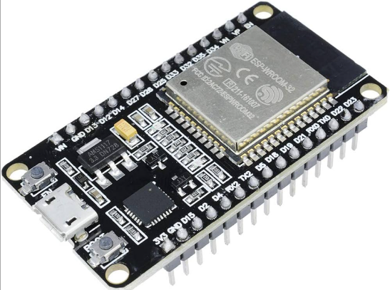

Fig.3.1 ESP32

The ESP32 is a powerful Wi-Fi and Bluetooth module developed by Espressif Systems, a company recognized for its advancements in Internet of Things (IoT) and wireless communication technologies. As the successor to the popular ESP8266 series, the ESP32 offers enhanced performance, dual-core processing, and integrated support for both Wi-Fi and Bluetooth (Classic and BLE), making it highly versatile for a wide range of IoT applications. Known for its low power consumption, compact design, and rich set of features, the ESP32 is commonly used in smart home devices, wearable tech, industrial automation, and embedded systems that require both connectivity and computing power.
.

Features:
- Processing Power: Handles data from sensors and user interactions within the smart stick.
- Wi-Fi and Bluetooth Connectivity: Enables wireless communication for IoT applications.
- Compact Size: Fits easily into the smart stick design.
- Low Power Consumption: Extends battery life between charges.
- Multiple GPIO Pins: Allows easy connection to sensors, displays, and other peripherals.

Considerations:
- Power Consumption in Active Mode: Although it supports low power modes, power usage can still be relatively high during active processing or Wi-Fi/Bluetooth operations..
- Limited Built-in Storage : Some applications may need external memory for larger data handling or updates.

Overall:
- A strong choice for the smart stick due to its dual connectivity (Wi-Fi and Bluetooth), higher processing power, and flexibility.

Ultrasonic Sensor
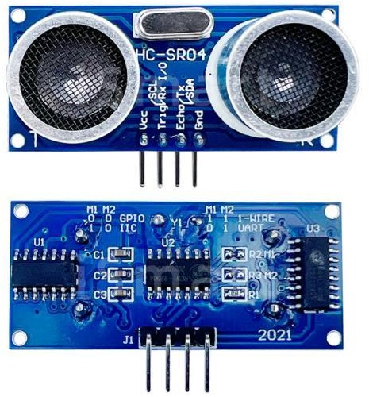

Fig. 3.2 UltraSonic Sensor

An ultrasonic sensor is a device that utilizes sound waves with frequencies higher than the upper audible limit of human hearing (typically above 20 kHz) to detect the presence of objects or measure distances. It works on the principle of echolocation, similar to how bats navigate in the dark.
Here's how an ultrasonic sensor typically works:
- Transmitter: The sensor emits ultrasonic waves, which are high-frequency sound waves, into the environment.
- Propagation: These sound waves travel through the air until they encounter an object in their path.
- Reflection: When the sound waves strike an object, they bounce off (or reflect) the surface of the object.
- Receiver: The sensor's receiver detects the echoes of these reflected sound waves.
- Time-of-Flight Measurement: By measuring the time it takes for the ultrasonic waves to travel from the transmitter to the object and back to the receiver, the sensor can calculate the distance to the object. This measurement principle is known as time-of-flight or pulse-echo measurement.

Ultrasonic sensors are commonly used for various purposes, including:
- Proximity Sensing: Detecting nearby objects or obstacles without physical contact.
- Distance Measurement: Calculating the distance to objects within their detection range.
- Obstacle Avoidance: Alerting systems to potential collisions and enabling navigation around obstacles.
- Liquid Level Measurement: Determining the level of liquid in tanks or containers.
- Object Detection: Identifying the presence or absence of objects in their field of view.

Pushbullet API



Fig. 3.3 Pushbullet API

Pushbullet API is a simple and powerful tool that allows anyone – even beginners – to send and receive messages, links, files, and notifications across their devices and apps. With just a basic understanding of API calls, users can connect their phone, tablet, or computer and instantly push content between them. Those new to Pushbullet can get started with basic push functionality in just a few minutes. And what’s more, its developer-friendly design makes it easy to integrate Pushbullet into more complex applications, saving time compared to building such features from scratch. The Pushbullet API aims to make seamless cross-device communication accessible to everyone, encouraging users to create smarter, more connected digital experiences.

A dedicated team of developers and contributors forms the heart of the Pushbullet project, supporting a growing community of tech enthusiasts and creators. In addition to maintaining and improving the Pushbullet API, this team provides documentation, tools, and support to help developers integrate real-time notifications and cross-device communication into their own projects. Thanks to their efforts, Pushbullet continues to power millions of users worldwide, offering a reliable and user-friendly platform for building smarter, more connected applications.

APIs like Pushbullet inspire both technical learning and creative problem-solving. But Pushbullet goes a step further by giving developers – even those just starting out – the tools to build applications that can improve daily life and communication. From instant notification systems to cross-device data sharing, Pushbullet has enabled individuals and teams to create real-world solutions with meaningful impact. In fact, developers around the world, both in classrooms and beyond, have used Pushbullet to connect people and technology in smarter, more helpful ways.

BUZZER

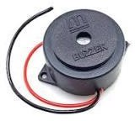

Fig 3.4 BUZZER

A buzzer is a simple yet versatile electromechanical device used to produce sound when an electrical current passes through it. It finds widespread use in a variety of applications, including alarm systems, electronic gadgets, musical instruments, and industrial equipment. Despite its straightforward construction, the buzzer plays a vital role in providing audible alerts, notifications, and feedback in numerous contexts.

Fundamentally, a buzzer operates based on the principle of electromagnetic induction. It typically consists of a coil of wire wound around a magnetic core, often made of materials like iron or ferrite. When an electrical current flows through the coil, it generates a magnetic field around the core. This magnetic field interacts with a diaphragm or an armature connected to the core, causing it to vibrate rapidly.

As the diaphragm or armature vibrates, it displaces the surrounding air, creating pressure waves that propagate as sound waves. The frequency and intensity of the sound produced depend on factors such as the rate of vibration of the diaphragm or armature and the characteristics of the magnetic core and coil.

Buzzers can be classified into two main types based on their mode of operation: active and passive buzzers. Active buzzers, also known as self-driven buzzers, include an internal oscillator circuit that generates an alternating current (AC) signal when voltage is applied to the device. This built-in oscillator produces the electrical signals needed to drive the buzzer, eliminating the need for an external oscillator or signal generator. Active buzzers are commonly used in applications where simplicity and ease of use are prioritized.

Passive buzzers, on the other hand, require an external alternating current (AC) or direct current (DC) signal to produce sound. These buzzers do not contain an internal oscillator circuit and rely on an external signal source to drive the vibrating diaphragm or armature. Passive buzzers are often found in applications where precise control over the frequency and duration of the sound output is desired.

NEO 6M GPS MODULE

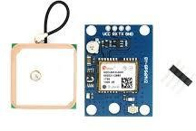

FIG 3.5 NEO 6M GPS MODULE

The NEO-6M GPS module, developed by U-Blox, represents a compact and affordable solution for a range of navigation and tracking needs. This module is prized for its reliable positioning accuracy and robust performance, all packed within a small form factor. Featuring a high-sensitivity receiver, the NEO-6M can acquire and track satellite signals even in challenging environments, ensuring consistent and precise location data. Moreover, its support for multiple satellite constellations, including GPS and GLONASS, enhances positioning accuracy and availability, especially in areas where satellite visibility may be obstructed. One of the notable attributes of the NEO-6M is its fast time-to-first-fix (TTFF), enabled by advanced positioning algorithms and signal processing capabilities. This allows for rapid satellite signal acquisition and position determination, particularly crucial during initial power-up or signal loss scenarios. Communication with external devices is facilitated through a standard serial interface (UART), making integration seamless with various hardware platforms. The compact design of the NEO-6M further enhances its versatility, making it suitable for diverse applications such as GPS trackers, wearable devices, unmanned aerial vehicles (UAVs), and vehicle navigation systems. Overall, the NEO-6M GPS module offers a blend of reliability, performance, and affordability, making it a preferred choice among hobbyists, enthusiasts, and professionals seeking accurate positioning and navigation solutions.

Vibration Motor

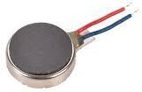

Fig 3.6 Vibration Motor

A vibration motor is a small electro mechanical device designed to produce vibrations when an electrical signal is applied to it. These motors are commonly used in various electronic devices and gadgets to provide tactile feedback or alerts to users.
The basic principle of operation of a vibration motor involves the conversion of electrical energy into mechanical vibrations. Inside the motor, there is typically a small eccentric weight attached to the motor shaft. When an electrical current is passed through the motor's coils, it generates a magnetic field that interacts with the permanent magnets inside the motor. This interaction causes the motor shaft, and thus the attached eccentric weight, to rotate rapidly, creating unbalanced forces that result in vibrations.

Vibration motors come in various sizes and shapes, ranging from tiny coin-sized motors used in mobile phones and wearable devices to larger motors used in gaming controllers and industrial equipment. They can produce vibrations of different intensities and frequencies depending on the design and specifications of the motor.

In electronic devices, vibration motors are often used to provide tactile feedback to users, such as in smartphones, where they are used to alert users of incoming calls, messages, or notifications. They are also commonly used in handheld gaming devices to enhance the gaming experience by providing feedback during gameplay. Additionally, vibration motors find applications in industrial equipment for tasks such as conveying, compacting, and sorting materials.

Flame Sensor

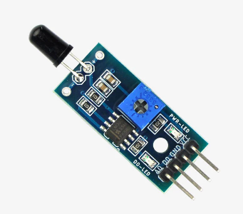

Fig 3.7 Flame Sensor

A flame sensor is a device designed to detect the presence of a flame or fire. It plays a critical role in safety and automation systems by identifying whether a flame is present or not, and triggering a response if necessary. These sensors are commonly found in gas-powered appliances, fire alarm systems, and various types of industrial equipment where monitoring for fire is essential.

The working principle of a flame sensor is based on detecting specific wavelengths of light produced by a flame. Most flames emit infrared (IR) or ultraviolet (UV) light, which cannot be easily seen by the human eye. The flame sensor uses a photodiode or phototransistor that is sensitive to these wavelengths. When a flame is present, the sensor captures the emitted light and converts it into an electrical signal that can be processed by a microcontroller or alarm system.

Flame sensors come in different types, such as IR flame sensors, UV flame sensors, and flame detectors that work using visible light. Each type is selected based on the application and the environment in which it is used. For example, UV flame sensors are often used in indoor systems where the presence of sunlight won't interfere, while IR flame sensors are better suited for outdoor or harsh conditions.

In practical use, flame sensors are widely integrated into systems for fire detection and safety shutdowns. In a gas stove or boiler, the sensor ensures that the burner is lit; if no flame is detected, the system cuts off the gas supply to prevent leaks. In fire alarm systems, flame sensors can provide a fast and accurate method for detecting fire, allowing for quicker response times and improved safety.

PROJECT TYPES

Project Description: The Smart Stick is an innovative assistive device designed to enhance the navigation and safety of visually impaired individuals. It integrates advanced technologies to provide real-time feedback and assistance, empowering users to navigate their surroundings confidently and independently.

Features:
- Obstacle Detection: The Smart Stick is equipped with ultrasonic sensors that detect obstacles in the user's path. These sensors provide immediate feedback, alerting the user to potential hazards and helping them avoid collisions.
- Fire Hazard Detection: A flame sensor is integrated into the Smart Stick to detect fire hazards in the surrounding environment. In the event of a fire, the sensor triggers an alert, allowing the user to evacuate safely.
- GPS Tracking system: The device includes a GPS module that provides real-time location tracking. This feature enables caregivers or family members to monitor the user's location remotely and provide assistance if needed.
- Real Time Feedback: A vibration motor provides tactile feedback to the user, signaling the presence of obstacles or alerting them to emergency situations. This feedback mechanism enhances situational awareness and improves safety.
- SOS Button: The Smart Stick features an emergency button that users can press to trigger distress signals. In emergency situations, the device activates the alert notification feature, notifying designated contacts for immediate assistance.
- Mobile App Integration: The Smart Stick communicates with a companion mobile application, allowing users to visualize data, monitor location, and customize settings. The app provides an intuitive interface for accessing features and managing preferences.
- User-friendly build: Designed with usability in mind, the Smart Stick features ergonomic grips and intuitive controls for ease of use. Its lightweight and portable design make it convenient for everyday use.
- Durable Design: The Smart Stick is built to withstand daily use, with durable materials and weather-resistant components. Its robust construction ensures reliability in various environments and conditions

HARDWARE REQUIREMENTS FOR DEVELOPER AND
END USER

Hardware Requirements:

    - Microcontroller: A microcontroller serves as the brain of the Smart Stick, controlling its operation and managing input/output devices. Common choices include Arduino boards or Raspberry Pi.
    - Ultrasonic Sensors: Ultrasonic sensors are used for object detection. They emit ultrasonic waves and measure the time it takes for the waves to bounce back from obstacles, determining their distance from the Smart Stick.
    - IR Sensor: In addition to ultrasonic sensors, an IR sensor can be employed for object detection. It detects infrared radiation emitted by nearby objects, providing an alternative method for obstacle detection.
    - Flame Sensor: A flame sensor detects the presence of fire hazards in the environment. It triggers an alert when flames are detected, enhancing safety.
    - GPS Module (NEO-6M): The GPS module provides real-time location tracking, allowing users to monitor their position and receive assistance if needed. The NEO- 6M GPS module is a commonly used module for its accuracy and reliability.
    - Vibration Motor: A vibration motor provides tactile feedback to the user, alerting them to obstacles or emergency situations.
    - Buttons: Buttons are used for user input, such as requesting distance information or triggering emergency alerts.
    - Battery: A rechargeable battery powers the Smart Stick, providing portability and extended usage time.

SOFTWARE REQUIREMENTS FOR DEVELOPER AND END USER

Software Requirements:

    - Arduino IDE: The Arduino Integrated Development Environment (IDE) serves as the primary platform for writing, compiling, and uploading code to the microcontroller. It supports programming in C/C++ and provides a user-friendly interface for managing projects and libraries.

    - Embedded C/C++ Programming: C/C++ programming language is used within the Arduino IDE for developing firmware to control the Smart Stick's operation. This involves writing code to interface with hardware components, process sensor data, and implement navigation algorithms.

    - Pushbullet API: Pushbullet API is a simple and powerful tool that allows developers to send notifications, links, messages, or files between devices and users in real time. It’s commonly used in automation and IoT projects to deliver alerts or updates directly to a user’s phone or browser, helping create a more connected and responsive system..

CHAPTER-04 METHODOLOGY

METHODOLOGY

Planning of the Project: Define the scope of the project, including the specific tasks to be automated in the lab, the expected outcomes, and the timeline. Identify the necessary hardware and software components, including the ESP32 microcontroller, sensors, actuators, and communication protocols.
Hardware Configuration: Assemble and configure the necessary hardware components, including the ESP32 microcontroller, sensors, and actuators. Connect them according to the project requirements and specifications, ensuring proper power supply and grounding.
Application Development: Develop the software for the ESP32 microcontroller using an appropriate programming language, such as Arduino IDE. Implement the logic and algorithms required for smart stick. including data acquisition from sensors, data processing, and control of actuators. Ensure efficient communication with other devices, such as a central server or a user interface
Sensor Adjustment and Validation: Calibrate the sensors to ensure accurate and reliable measurements. Perform extensive testing of the sensor readings and the overall system behavior in different scenarios and conditions to validate its functionality and performance.
Interaction and Unification: Established communication between the ESP32 microcontroller and other devices or systems, such as a central server or user interface.
UI Design and Implementation: Develop a user interface, such as a web-based dashboard or a mobile app, to allow users to interact . Implement features such as real-time monitoring, data visualization, and user controls to enable easy and intuitive operation of the system
System Integration and Testing: Integrate all the hardware and software components into a cohesive system. Conduct comprehensive testing of the integrated system to validate its overall functionality performance, and reliability. Make necessary adjustments and improvements as need.
Documentation: Create documentation, including user manuals, technical specifications, and system diagrams, to provide comprehensive guidance on how to use and maintain the smart stick.
System Servicing: Provide ongoing maintenance and support for the smart stick, including periodic updates, troubleshooting, and technical assistance as needed to ensure its continued operation and performance.

METHODOLOGY DESCRIPTION

Methodology Description for Smart Stick Project:

- Requirement Gathering: Conduct a comprehensive analysis to understand the specific needs and challenges faced by visually impaired individuals. Engage with potential users, caregivers, and stakeholders to gather insights and define key requirements for the Smart Stick. Identify functionalities such as obstacle detection, fire hazard detection, navigation assistance, and emergency response.

- Choosing Appropriate Sensor: Evaluate available sensor options and select appropriate sensors based on the identified requirements. Consider factors such as range, accuracy, power consumption, and integration capabilities. Common sensors may include ultrasonic sensors for obstacle detection, IR sensors for proximity sensing, flame sensors for fire hazard detection, and GPS modules for location tracking.

- Hardware Configuration: Acquire and set up the hardware components required for the Smart Stick. This includes selecting a microcontroller board (e.g., Arduino Uno or Raspberry Pi), connecting sensors and actuators (such as vibration motors and buttons), and configuring power sources (e.g., rechargeable batteries). Ensure proper wiring and connections according to datasheets and technical specifications.

- Firmware Development: Develop firmware for the microcontroller using the Arduino IDE and C/C++ programming language. Implement algorithms to process sensor data, detect obstacles and fire hazards, calculate distances, and provide feedback to the user through vibration motors and Buzzer indicators. Test and debug the firmware to ensure reliable and accurate operation.

- User Interface Design: Design the user interface for the Smart Stick's companion mobile application using Pushbullet API. Create intuitive interfaces for users to interact with the device, visualize sensor data, customize settings, and receive alerts. Ensure accessibility features are incorporated to accommodate visually impaired users, such as voice-guided navigation and high-contrast visuals.

- Integration and Verification: Integrate the firmware with the mobile application and test the complete system for functionality, usability, and performance. Conduct comprehensive testing under various environmental conditions to validate sensor accuracy, navigation effectiveness, and emergency response capabilities. Solicit feedback from potential users and stakeholders for further refinement.

- Performance Tuning and Enhancement: Optimize the hardware and software components of the Smart Stick for efficiency, reliability, and power consumption. Fine-tune algorithms and parameters to improve obstacle detection accuracy, reduce false positives, and enhance user experience. Iterate on the design based on user feedback and testing results.

- Documentation and Implementation: Document the project's methodology, design decisions, implementation details, and testing procedures. Create user manuals and technical documentation to guide users in using and maintaining the Smart Stick. Deploy the finalized system for real-world use, providing training and support to end-users as needed.

CHAPTER-5

DESIGN OF PROJECT

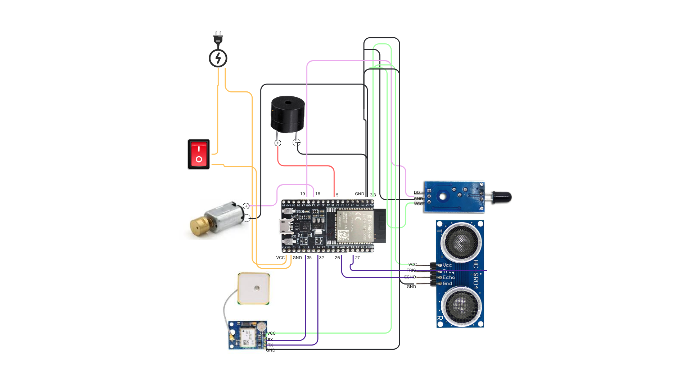
Fig : 5.1 CIRCUIT DIAGRAM

CHAPTER-6 ADVANTAGES OF THIS PROJECT

ADVANTAGES

- Enhanced Safety Measures: The Smart Stick offers real-time obstacle and fire hazard detection, ensuring visually impaired individuals can move safely and independently. By providing timely alerts, it helps minimize accidents and enhances personal security.

- Greater Mobility Assistance: Equipped with advanced sensors, the Smart Stick improves mobility by guiding users with confidence, reducing the need for external support, and fostering self-sufficiency.

- Live Location Monitoring: A built-in GPS system allows caregivers and family members to track the user's location remotely, ensuring safety and providing reassurance to loved ones.
- Quick Emergency Assistance: Featuring an emergency button with instant alert functionality, the Smart Stick allows users to seek help in critical situations, ensuring timely intervention and support.
- Easy-to-Use Interface: The companion mobile application, developed, provides a user-friendly experience with simple controls, making the device accessible and convenient to use.
- Cost-Effective and Widely Accessible: By leveraging open-source platforms like Arduino and App Inventor, the Smart Stick remains affordable, making assistive technology more accessible to a broader audience.
- Independence and Empowerment: By providing reliable navigation and safety features, the Smart Stick promotes self-reliance, boosting the confidence and autonomy of visually impaired individuals.
- Increased Awareness through Sensory Feedback: A vibration motor delivers tactile alerts for obstacles and hazards, enhancing the user's spatial awareness. Stronger vibrations are used to accommodate individuals with hearing impairments, ensuring better accessibility.

CHAPTER -7
APPLICATIONS OF PROJECT

APPLICATIONS

- Personal Navigation Companion: The Smart Stick serves as a practical navigation tool for visually impaired individuals, aiding them in safely traversing different environments.
- Indoor Wayfinding Support: It assists users in navigating enclosed spaces such as shopping malls, office buildings, and public transport hubs, improving accessibility and convenience.
- Educational and Awareness Initiatives: The Smart Stick project can be utilized for training programs and awareness campaigns to educate the public on visual impairment and assistive technology.
- Community Assistance Programs: Nonprofits and support organizations can implement the Smart Stick to enhance mobility solutions and resources for visually impaired individuals.
- Healthcare Facility Assistance: The Smart Stick helps visually impaired individuals confidently navigate hospitals, clinics, and other medical centers, making healthcare services more accessible.
- Caregiver Support Tool: Caregivers can rely on the Smart Stick's features to enhance safety for their visually impaired dependents, particularly in unfamiliar or crowded settings.

CHAPTER -8
LIMITATIONS OF PROJECT

LIMITATIONS

- Complexity in Initial Setup: Implementing the Smart Stick requires proper configuration and setup, which can be a challenge for large-scale users or those unfamiliar with assistive technology.
- Restricted Detection Range: Ultrasonic sensors have a limited detection range, meaning hazards beyond their reach may go unnoticed, posing potential risks.
- Vulnerability to Water Damage: The electronic components of the Smart Stick may be sensitive to moisture exposure, impacting reliability in rainy or humid conditions. Waterproofing solutions may increase durability but could add to the cost and design complexity.
- Ongoing Maintenance Needs: Like any electronic device, the Smart Stick requires regular maintenance, software updates, and troubleshooting support, which may not be equally accessible to all users.
- Learning and Adaptation Time: Users may need training to become fully accustomed to the Smart Stick’s features and feedback mechanisms, requiring initial guidance and practice.
- Battery Limitations: The reliance on rechargeable batteries introduces concerns regarding battery lifespan, degradation over time, and the need for frequent recharging. Proper power management strategies are essential for long-term usability.
- Privacy and Data Security Concerns: Features like GPS tracking and remote monitoring raise privacy issues regarding the handling of user location and personal data. Transparent data management policies and user consent controls are necessary.

RESULT/ SNAPSHOTS

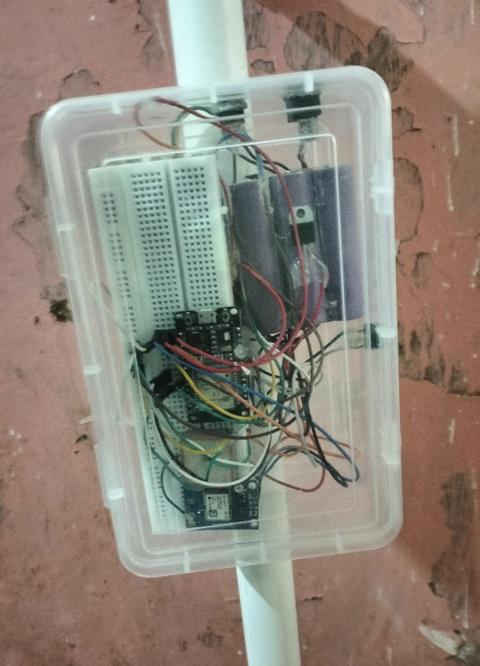

Fig R.1 Fire not detected

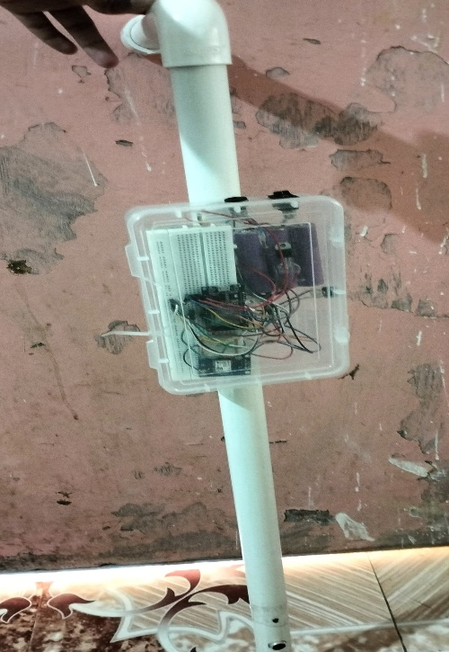

Fig R.2 Fire detected

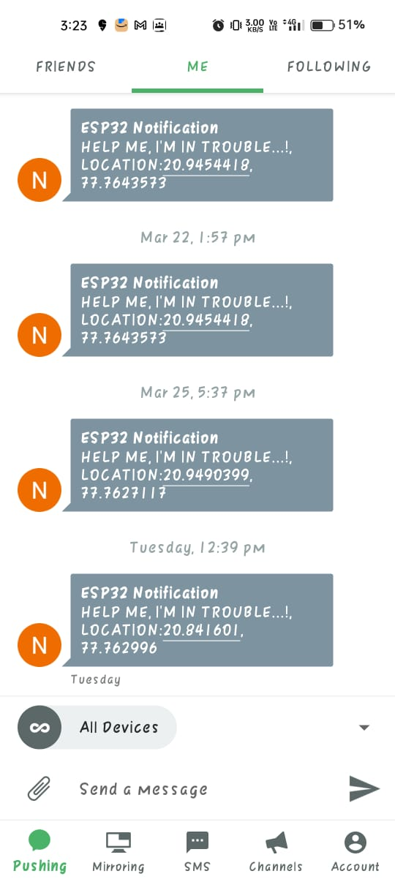
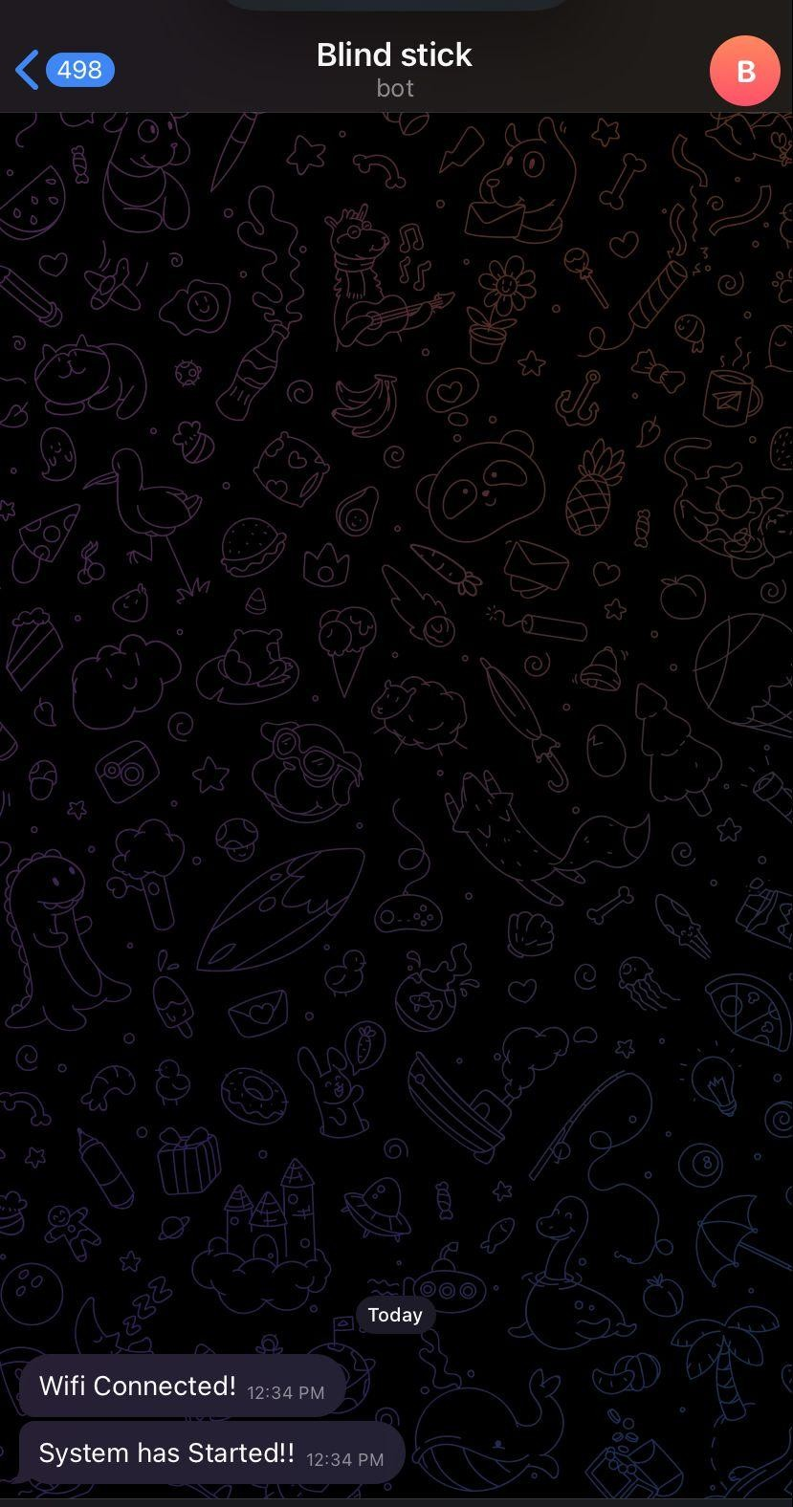
Fig R.5 When SOS Button is clicked

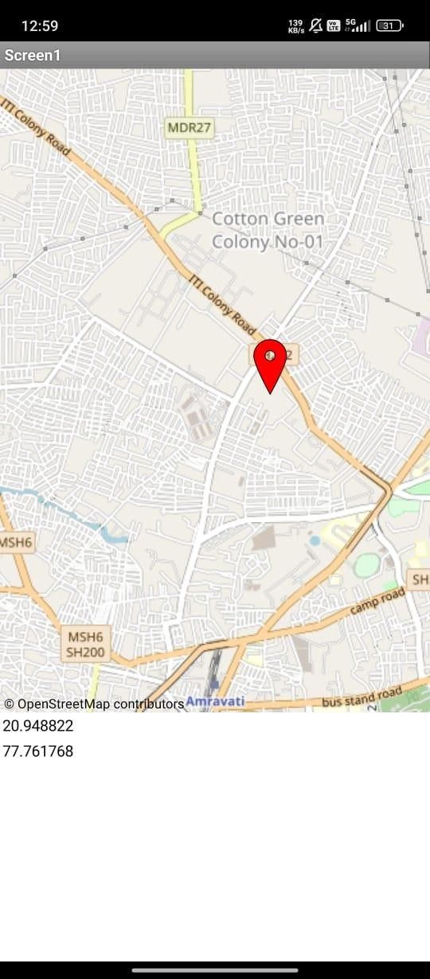

Fig R.6 Location on map

CONCLUSION

The Smart Stick project represents a significant breakthrough in assistive technology for visually impaired individuals. By integrating advanced sensor technologies and an intuitive design, it greatly enhances mobility and independence, allowing users to navigate with greater confidence.
Beyond its current capabilities, the Smart Stick has vast potential for further innovation, including AI-powered navigation, cloud connectivity, and health-monitoring features. Continuous development and user-driven enhancements will ensure the device remains effective and relevant in addressing accessibility challenges.
By fostering collaboration within the assistive technology community and prioritizing inclusivity, the Smart Stick sets a strong foundation for future advancements. As its features continue to evolve, it holds the promise of transforming the daily lives of visually impaired individuals, enabling greater autonomy and full participation in society.

FUTURE SCOPE

Future Smart Stick designs are set to become more intuitive and user-friendly through the integration of multisensory feedback, combining vibration, audio, and haptic responses. This will allow users to customize how they receive information based on personal preference and surrounding conditions, making navigation more accessible and responsive. Advanced sensors and AI will enable the stick to not only detect but also identify and classify obstacles—such as poles, benches, or moving bicycles—providing users with real-time, context-aware insights. Additionally, future models may feature smart traffic interaction capabilities, receiving signals from nearby traffic lights and crosswalks to alert users when it is safe to cross, significantly enhancing road safety. To improve ease of use and expand accessibility, future Smart Sticks could incorporate voice-controlled interfaces, allowing users to manage device functions or request assistance through simple voice commands. Offline navigation support using stored maps and routes will ensure reliable guidance even in areas with poor internet connectivity, such as rural or underdeveloped regions. Power efficiency will also be a priority, with advancements like solar-assisted charging, energy-efficient microcontrollers, and fast-charging options extending battery life and reducing downtime. Looking further ahead, features like community-based data sharing could allow users to report hazards and share environmental updates with one another. Emotional and mental wellbeing support may also be included through biometric sensors that monitor stress or heart rate, offering calming suggestions or alerting trusted contacts in times of distress—creating a holistic tool for physical navigation and emotional reassurance.

REFERENCES

  - Arduino : https://docs.arduino.cc/learn/starting-guide/the-arduino-software-ide/
  - Circuit Digest : https://circuitdigest.com/microcontroller-projects/interfacing-neo6m-gps-
  - Circuit Journal : https://circuitjournal.com/programming-esp8266-over-wifi
  - MIT Inventor : https://appinventor.mit.edu/
  - Creative Lab : https://lab.arts.ac.uk/books/physical-computing/page/using-a-vibration- motor#:~:text=It%20is%20commonly%20found%20inside,NPN%20transistor%20can%20b e%20used.
  - PushBullet : https://www.pushbullet.com/
  - Random Nerd :
- https://randomnerdtutorials.com/esp8266-nodemcu-hc-sr04-ultrasonic-arduino/
- https://randomnerdtutorials.com/esp8266-nodemcu-door-status-telegram/

